**Vaccination Management System**

**Group Members**

**AASHIR AAMIR BAIG  
Student 1398617**

**Submitted To**

[**eProjects@aglsm.com**](mailto:eProjects@aglsm.com)

**Project Instructor**

**Miss NEHA SHAH EJAZ**

**Curriculum Code**

**7062**

**MUHAMMAD SHAHEER**

**Student 1401788**

**MUHAMMAD UMAR**

**Student 1399562**

**Home Page**

Our Home Page.

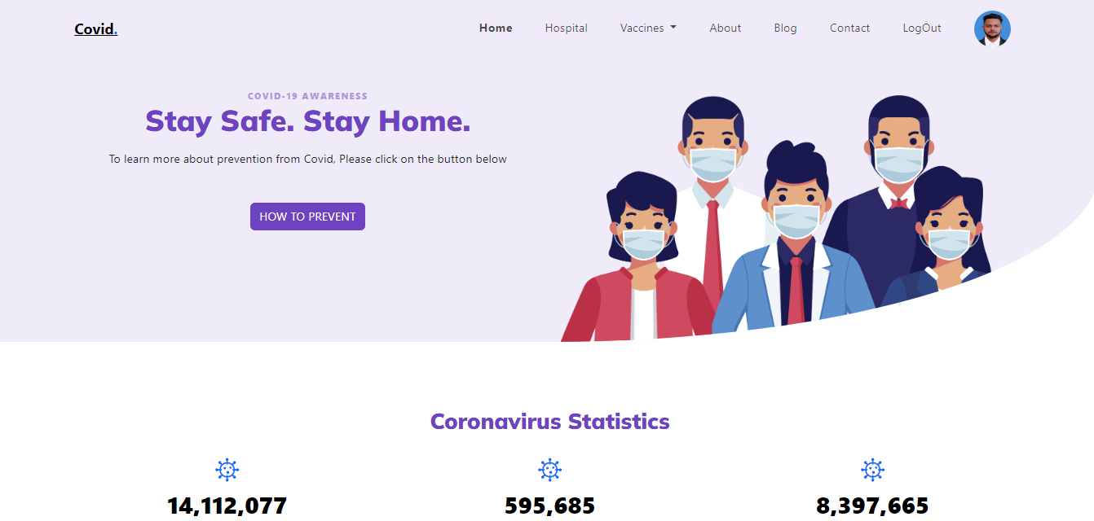

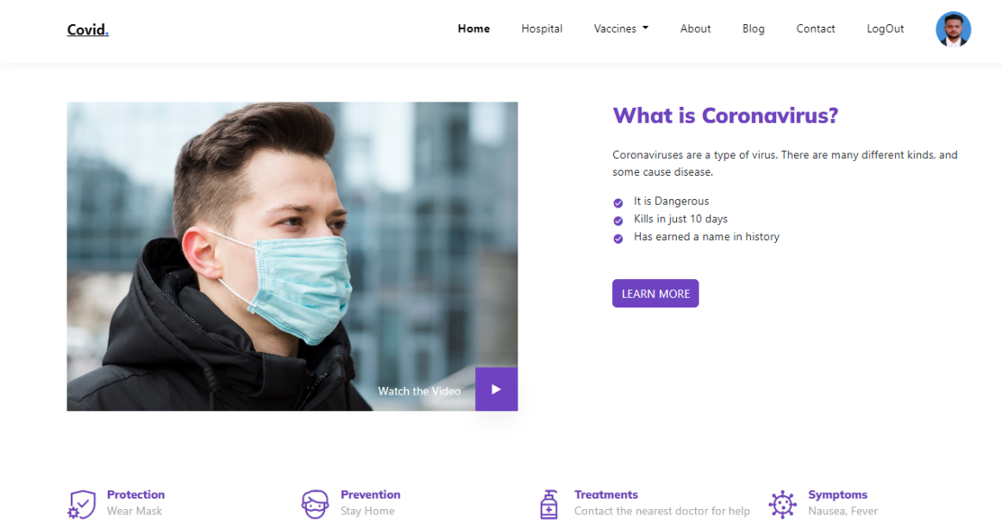

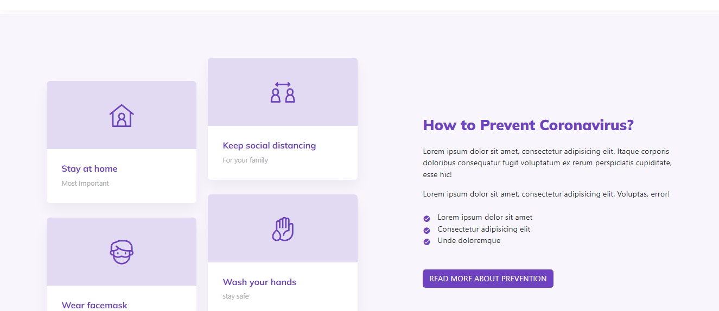

**Hospital**

From here we can see hospital

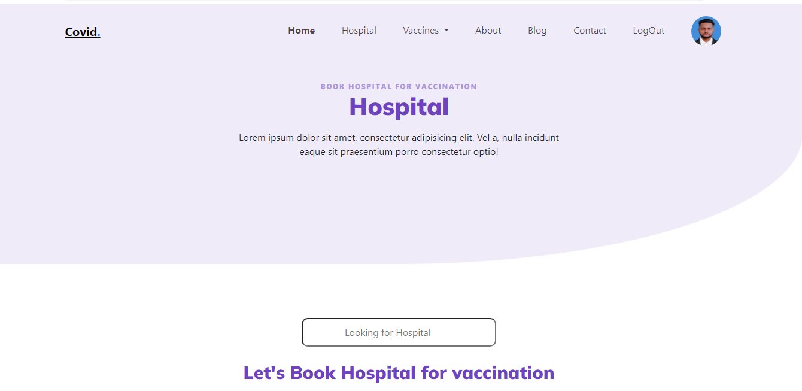

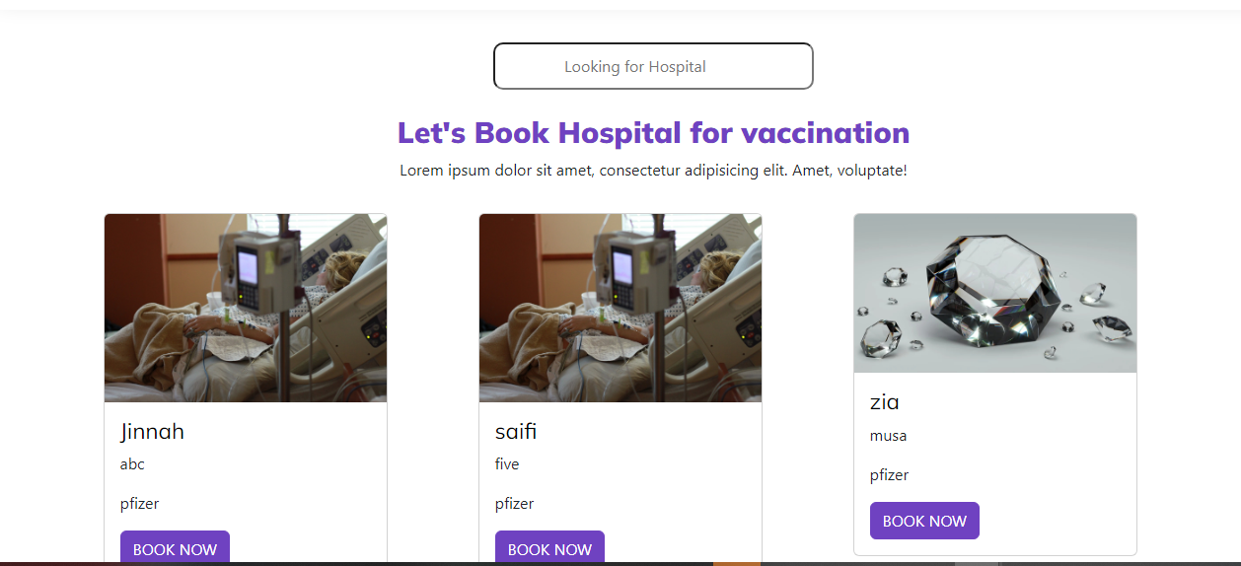

**Child information Form**

Parents will fill out form to get appointment

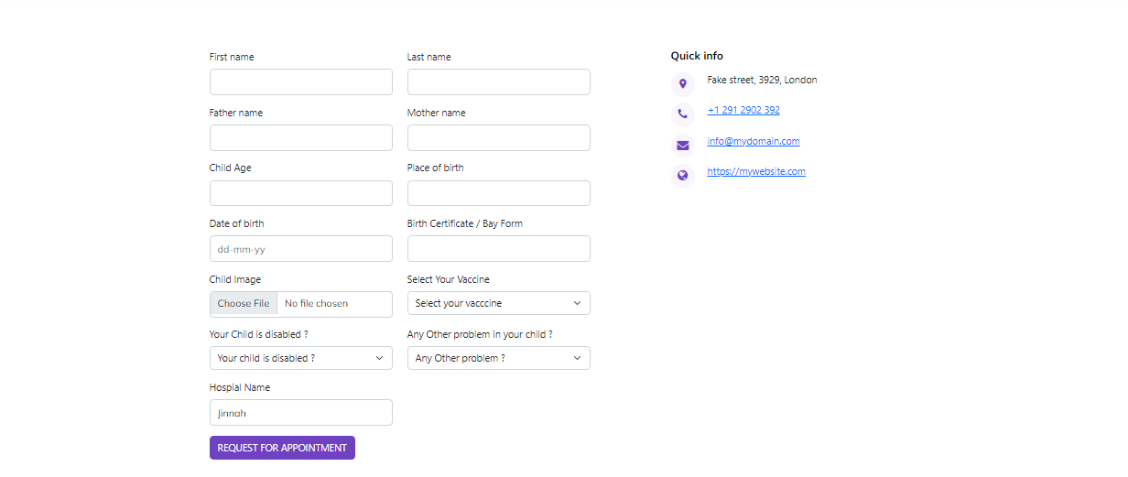

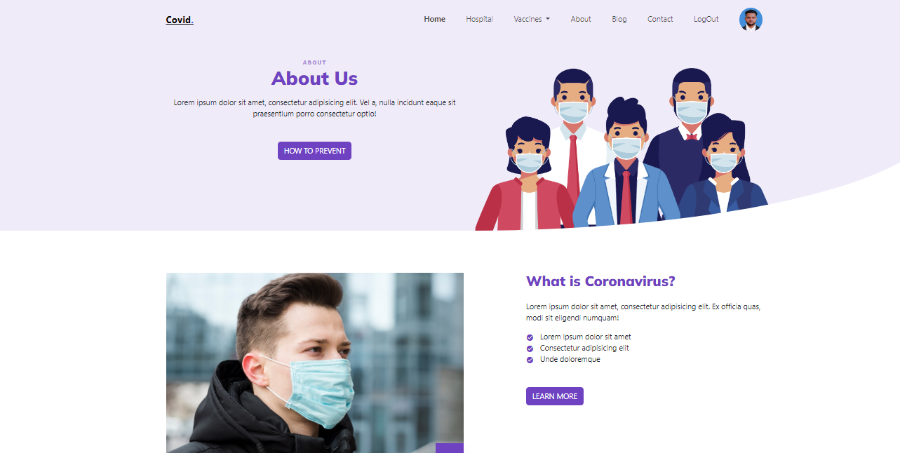**Vaccination**

**Contact Us**

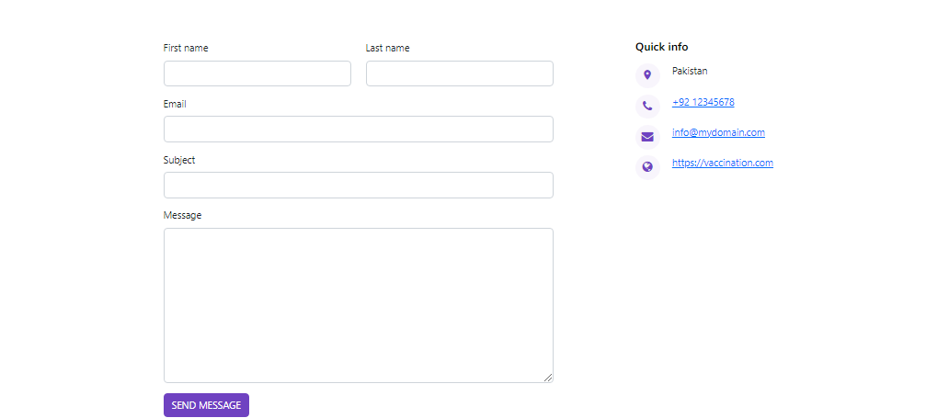

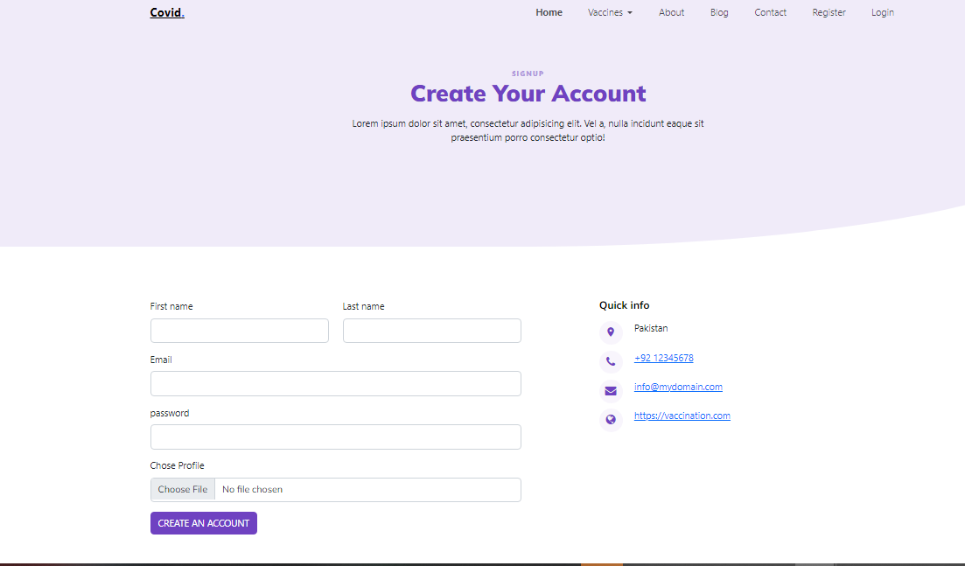**Registration Form**

**Admin Login Form**

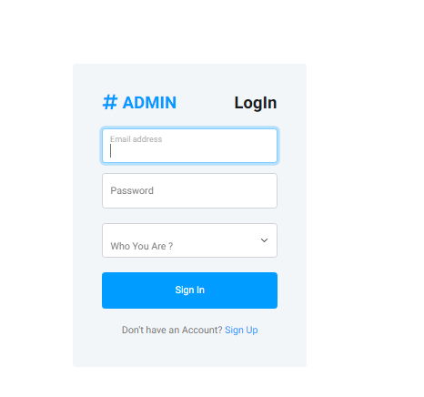

**Admin Child Details**

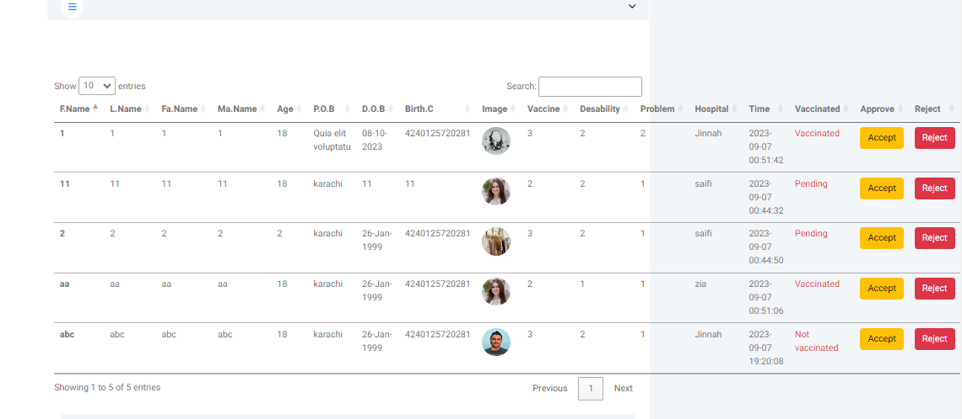

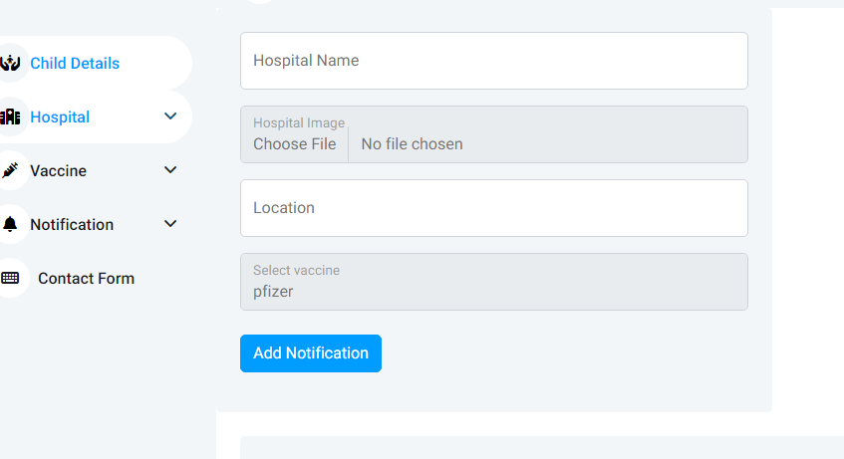**Add Hospital**

**Show Hospital**

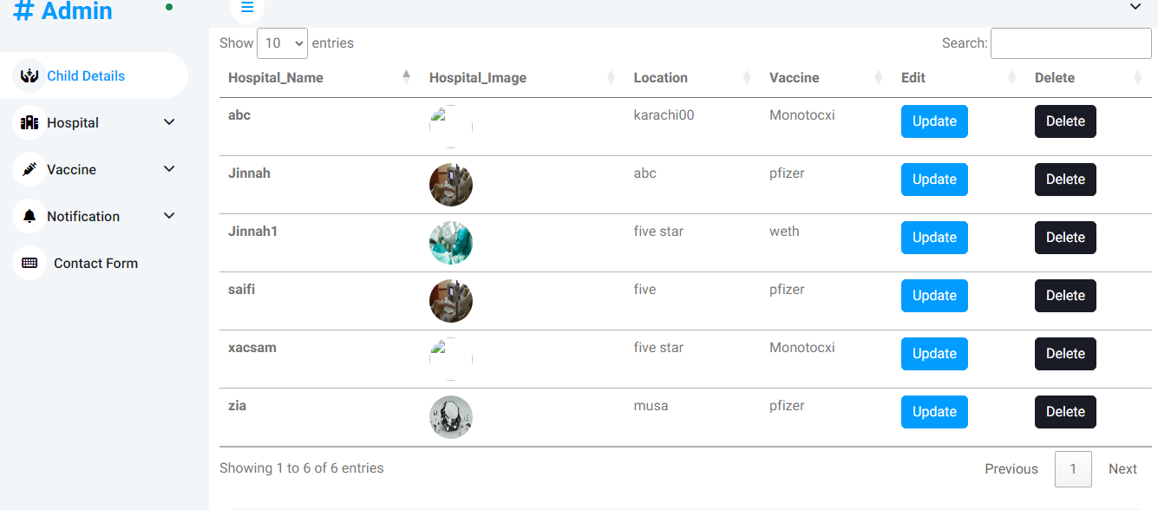

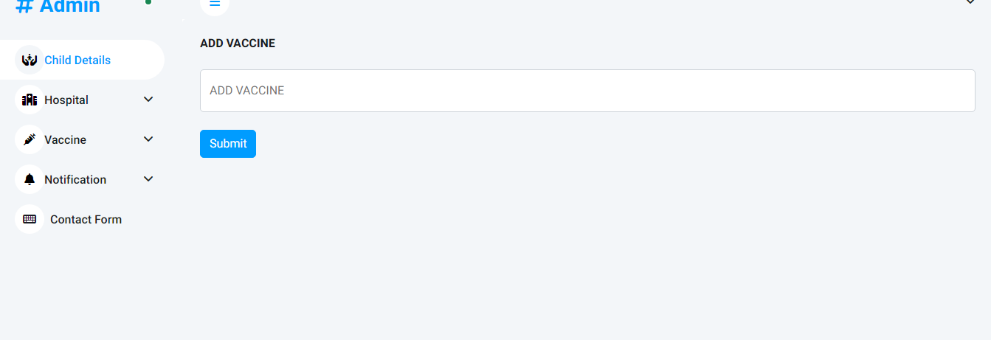**Add Vaccine**

**Update Vaccine**

